Machine Description | - Kioptrix Level 1 runs an outdated Apache with mod_ssl linked to OpenSSL 0.9.6b.  - Vulnerable routine: the TLS session cache serialization function i2d_SSL_SESSION does not properly initialize or bounds check the destination buffer.  - Cause: a specially crafted client certificate or malformed session payload can produce serialized session data larger than the buffer, causing a buffer overflow.  - Impact: exploitation can cause server crashes or enable remote code execution via the HTTPS service.
Target IP | 192.168.1.104
Vulnerability Name | Buffer Overflow in the session cache serialization
Severity and Base Score | 9.8 / Critical
Attack Vector | AV:N/AC:L/PR:N/UI:N/S:U/C:H/I:H/A:H
Proof of Concept | STEP 1 : ( Host Discovery using Netdiscover )  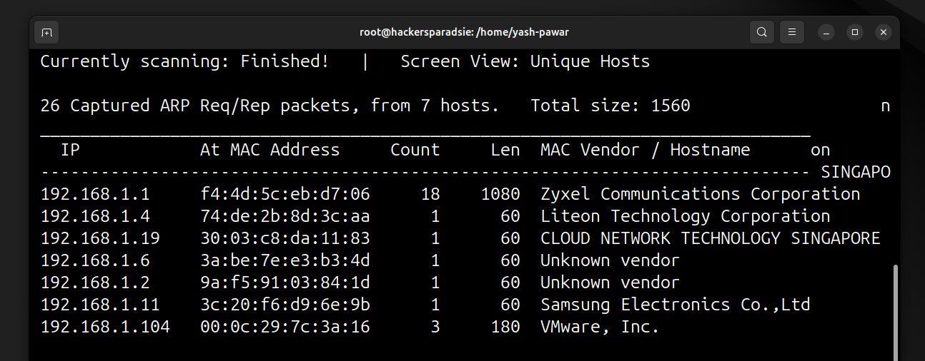  STEP 2 : ( Service Version Detection scan using Nmap )  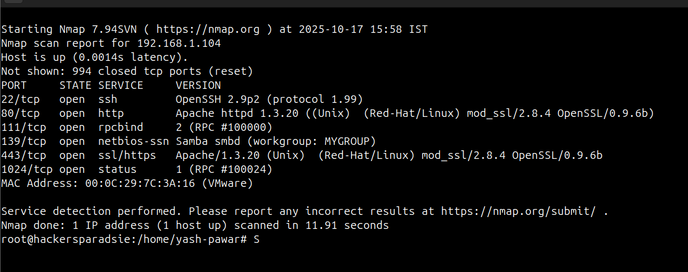  STEP 3 : ( As we can see there is outdated mod_ssl/2.8.4 running on target. Found exploit online And we got one exploit on ExpolotDB )  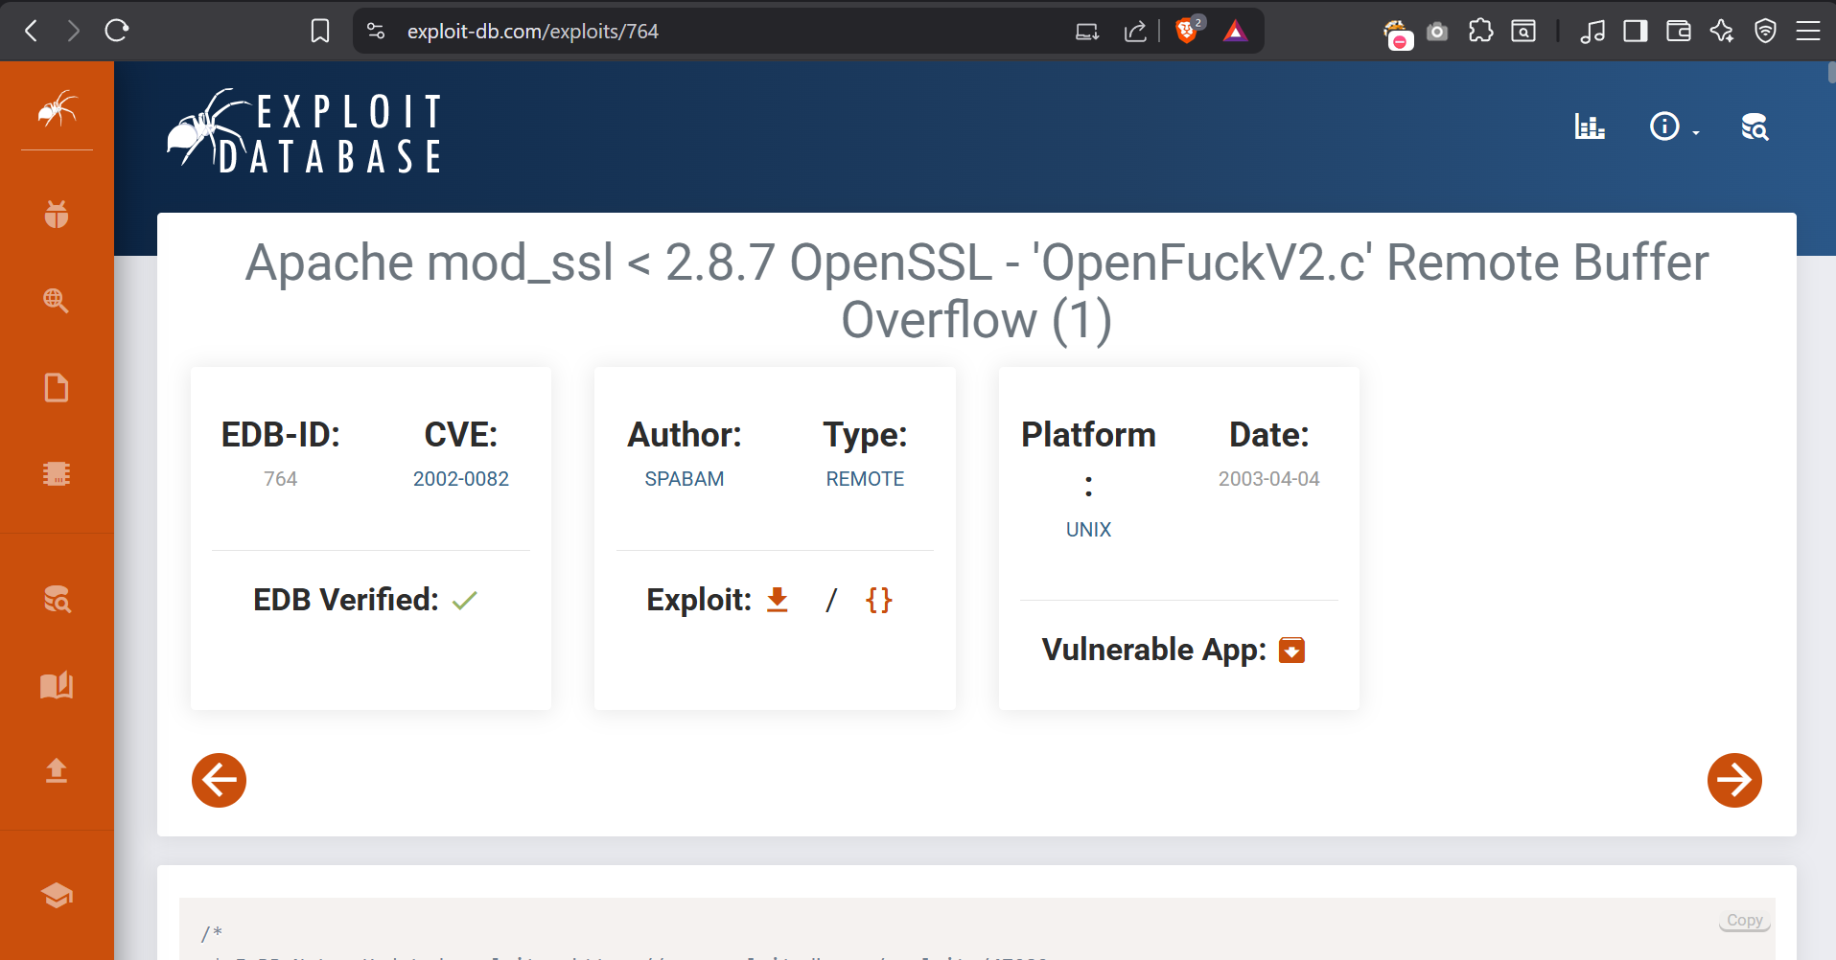  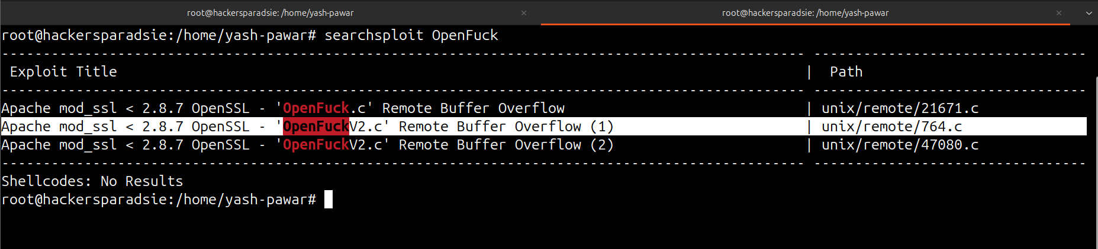  STEP 4 : Fixed and Compiled Exploit For execution  STEP 5 : ( Copy and Configure exploit and make it ready for compiling )  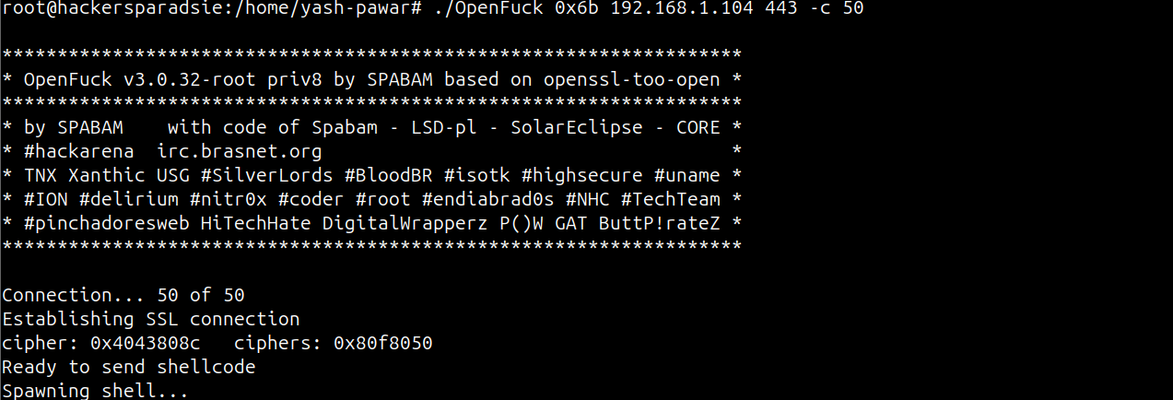  STEP 6 : ( Got Root Access and updated password )  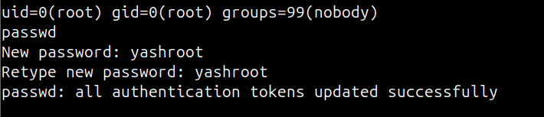
Impact | - Allows remote code execution or denial of service on the web server  - Attacker can access sensitive files like configuration and keys  - Enables modification of web content, logs, or stored data  - Can crash services, causing disruption and potential operational impact
Remediations | - Upgrade OpenSSL and mod_ssl to versions that have patched the session serialization vulnerability.  - Disable SSLv2 and SSLv3 and enforce the use of modern TLS versions.  - Replace certificates and regenerate keys if compromise is suspected.  - Monitor server processes and logs for crashes or unusual behaviour to detect exploitation attempts.
References | https://nvd.nist.gov/vuln/detail/CVE-2002-0082?utm_source=chatgpt.com  https://httpd.apache.org/docs/current/mod/mod_ssl.html?utm_source=chatgpt.com

